**FAST NEAREST NEIGHBOR SEARCH IN KEYWORDS**

**CHAPTER 1**

**INTRODUCTION**

With the enormous amount of data stored in files, databases, and other repositories, it is increasingly important, if not necessary, to develop powerful means for analysis and perhaps interpretation of such data and for the extraction of interesting knowledge that could help in decision-making.

*Data Mining*, also popularly known as *Knowledge Discovery in Databases* (KDD), refers to the nontrivial extraction of implicit, previously unknown and potentially useful information from data in databases. While data mining and knowledge discovery in databases (or KDD) are frequently treated as synonyms, data mining is actually part of the knowledge discovery process

The Knowledge Discovery in Databases process comprises of a few steps leading from raw data collections to some form of new knowledge. The iterative process consists of the following steps:

* **Data cleaning**: also known as data cleansing, it is a phase in which noise data and irrelevant data are removed from the collection.
* **Data integration**: at this stage, multiple data sources, often heterogeneous, may be combined in a common source.
* **Data selection**: at this step, the data relevant to the analysis is decided on and retrieved from the data collection.
* **Data transformation**: also known as data consolidation, it is a phase in which the selected data is transformed into forms appropriate for the mining procedure.
* **Data mining**: it is the crucial step in which clever techniques are applied to extract patterns potentially useful.
* **Pattern evaluation**: in this step, strictly interesting patterns representing knowledge are identified based on given measures.
* **Knowledge representation**: is the final phase in which the discovered knowledge is visually represented to the user. This essential step uses visualization techniques to help users understand and interpret the data mining results.

A spatial database manages multidimensional objects (such as points, rectangles, etc.), and provides fast access to those objects based on different selection criteria. The importance of spatial databases is reflected by the convenience of modeling entities of reality in a geometric manner. For example, locations of restaurants, hotels, hospitals and so on are often represented as points in a map, while larger extents such as parks, lakes, and landscapes often as a combination of rectangles. Many functionalities of a spatial database are useful in various ways in specific contexts. For instance, in a geography information system, range

search can be deployed to find all restaurants in a certain area, while nearest neighbor retrieval can discover the restaurant closest to a given address. Today, the widespread use of search engines has made it realistic to write spatial queries in a brandnew way. Conventionally, queries focus on objects’ geometric properties only, such as whether a point is in a rectangle, or how close two points are from each other. We have seen some modern

applications that call for the ability to select objects based on both of their geometric coordinates and their associated texts. For example, it would be fairly useful if a search engine can be used to find the nearest restaurant that offers “steak, spaghetti, and brandy” all at the same time. Note that this is not the “globally” nearest restaurant (which would have been returned by a traditional nearest neighbour query), but the nearest restaurant among only those providing all the demanded foods and drinks. There are easy ways to support queries that combine spatial and text features. For example, for the above que.ll.ry, we could first fetch all the restaurants whose menus contain the set of keywords {steak, s00paghetti, brandy}, and then from the retrieved restaurants, find the nearest one. Similarly, one could also do it reversely by targeting first the spatial conditions—browse all the restaurants in ascending order of their distances to the query point until encountering one whose menu has all the keywords. The major drawback of these straightforward approaches is that they will fail to provide real time answers on difficult inputs. A typical example is that the real nearest neighbour lies quite far away from the query point, while all the closer neighbours are missing at least one of the query keywords.

**Abstract:**

Conventional spatial queries, such as range search and nearest neighbor retrieval, involve only conditions on objects’ geometric properties. Today, many modern applications call for novel forms of queries that aim to find objects satisfying both a spatial predicate, and a predicate on their associated texts. For example, instead of considering all the restaurants, a nearest neighbor query would instead ask for the restaurant that is the closest among those whose menus contain “steak, spaghetti, brandy” all at the same time. Currently the best solution to such queries is based on *the IR*2*-tree*, has a few deficiencies that seriously impact its efficiency. Motivated by this, we develop a new access method called *the spatial inverted index* that extends the conventional inverted index to cope with multidimensional data, and comes with algorithms that can answer nearest neighbor queries with keywords in real time. The proposed techniques outperform the IR2-tree in query response time significantly, often by a factor of orders of magnitude.

**Architecture:**

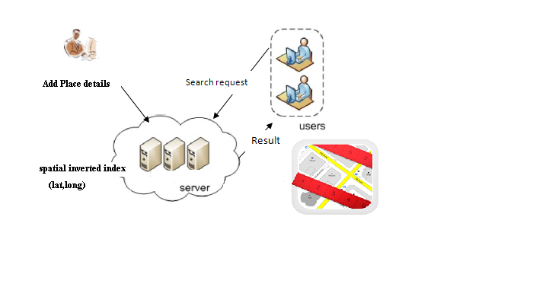

**LITERATURE REVIEW**

**DBXplorer: A System for Keyword-Based Search over Relational Databases**

Internet search engines have popularized the keyword based search paradigm. While traditional database management systems offer powerful query languages, they do not allow keyword-based search. In this paper, discuss DBXplorer, a system that enables keyword based search in relational databases. DBXplorer has been implemented using a commercial relational database and web server and allows users to interact via a browser front-end. extensive experimental evaluation.

**Efficient Query Processing in Geographic Web Search Engines**

Geographic web search engines allow users to constrain and order search results in an intuitive manner by focusing a query on a particular geographic region. Geographic search technology, also called *local search*, has recently received significant interest from major search engine companies. Academic research in this area has focused primarily on techniques for extracting geographic knowledge from the web. In this paper, we study the problem of efficient query processing in scalable geographic search engines. Query processing is a major bottleneck in standard web search engines, and the main reason for the thousands of machines used by the major engines. Geographic search engine query processing is different

in that it requires a combination of text and spatial data processing techniques.Proposed several algorithms for efficient query processing in geographic search engines, integrate them into an existing web search query processor, and evaluate them on large sets of real data and query traces.

**Collective Spatial Keyword Querying**

With the proliferation of geo-positioning and geo-tagging, spatial web objects that possess both a geographical location and a textual description are gaining in prevalence, and spatial keyword queries that exploit both location and textual description are gaining in prominence. However, the queries studied so far generally focus on finding individual objects that each satisfy a query rather than finding groups of objects where the objects in a group collectively satisfy a query.

Define the problem of retrieving a group of spatial web objects such that the group’s keywords cover the query’s keywords and such that objects are nearest to the query location and have the lowest inter-object distances.

**EXISTING SYSTEM:**

Spatial queries with keywords have not been extensively explored. In the past years, the community has sparked enthusiasm in studying keyword search in relational databases. It is until recently that attention was diverted to multidimensional data. Existing works mainly focus on finding top-k Nearest Neighbours, where each node has to match the whole querying keywords .It does not consider the density of data objects in the spatial space. Also these methods are low efficient for incremental query.

**Drawbacks of Existing System**

* The existing solutions to such queries either incur prohibitive space consumption or are unable to give real time answers

**PROPOSED SYSTEM:**

A spatial database manages multidimensional objects (such as points, rectangles, etc.), and provides fast access to those objects based on different selection criteria. The importance of spatial databases is reflected by the convenience of modeling entities of reality in a geometric manner. For example, locations of restaurants, hotels, hospitals and so on are often represented as points in a map, while larger extents such as parks, lakes, and landscapes often as a combination of rectangles. Many functionalities of a spatial database are useful in various ways in specific contexts. For instance, in a geography information system, range search can be deployed to find all restaurants in a certain area, while nearest neighbor retrieval can discover the restaurant closest to a given address.

**Advantages of Proposed System**

* SI-index is fairly space economical
* Ability to perform keyword-augmented nearest neighbor search in time

CHAPTER 2

**SYSTEM REQUIREMENTS**

**HARDWARE**

* CPU : Intel Pentium IV 600MHz
* Mother Board : Intel 810
* Hard disk space : 20GB or more
* Display : 15‖ Monitor
* Memory : 128 MB RAM
* Other Devices : Color Monitor, Keyboard, mouse.

CHAPTER 3

**MODULES DESCRIPTION**

* Spatial Inverted Index
* Enhanced Search
* Nearest Neighbor Search
* Google Map Api
* Finding Route

**SPATIAL INVERTED INDEX**

An SI-index preserves the spatial locality of data points, and comes with an R-tree built on every inverted list at little space overhead. As a result, it offers two competing ways for query processing. We can (sequentially) merge multiple lists very much like merging traditional inverted lists by ids. Alternatively, we can also leverage the R-trees to browse the points of all relevant lists in ascending order of their distances to the query point. It contains the set of points and the points are related to the set of keywords and the keywords are related to derive the set of documents. Here using the new concepts of the merge list and the distance alignment to retrieve the documents from the user requirement.

**ENHANCED SEARCH**

The enhanced search is used to effectively search the data’s based on the priority level. By using this search we get the data’s depending upon the user priority levels. It means user enter the key words for search data’s at the same time we include the priority box.After entering the priority the database ranking the documents to display the required documents.

‣ For each keyword

find spatial objects that contain the keyword

- Intersect them

- For each object,

compute distance to query point

- Sort and return

**Nearest Neighbor Search**

Nearest neighbor search (NNS), also known as proximity search, similarity search or closest point search, is an optimization problem for finding closest (or most similar) points. Formally, the nearest-neighbor (NN) search problem is defined as follows: given a set *S* of points in a space *M* and a query point *q* ∈ *M*, find the closest point in *S* to *q*.

**Calculate distance, bearing and more between Latitude/Longitude points**

const pi = 3.14159265358979323846

Function distance(lat1, lon1, lat2, lon2, unit)

Dim theta, dist

theta = lon1 - lon2

dist = sin(deg2rad(lat1)) * sin(deg2rad(lat2)) + cos(deg2rad(lat1)) * cos(deg2rad(lat2)) * cos(deg2rad(theta))

dist = acos(dist)

dist = rad2deg(dist)

distance = dist * 60 * 1.1515

Select Case ucase(unit)

Case "K"

distance = distance * 1.609344

Case "N"

distance = distance * 0.8684

End Select

End Function

'::::::::::::::::::::::::::::::::::::::::::::::::::::::::::::::::::::::

'::: This function get the arccos function from arctan function :::

'::::::::::::::::::::::::::::::::::::::::::::::::::::::::::::::::::::::

Function acos(rad)

If Abs(rad) <> 1 Then

acos = pi/2 - Atn(rad / Sqr(1 - rad * rad))

ElseIf rad = -1 Then

acos = pi

End If

End function

'::::::::::::::::::::::::::::::::::::::::::::::::::::::::::::::::::::::

'::: This function converts decimal degrees to radians :::

'::::::::::::::::::::::::::::::::::::::::::::::::::::::::::::::::::::::

Function deg2rad(Deg)

deg2rad = cdbl(Deg * pi / 180)

End Function

'::::::::::::::::::::::::::::::::::::::::::::::::::::::::::::::::::::::

'::: This function converts radians to decimal degrees :::

'::::::::::::::::::::::::::::::::::::::::::::::::::::::::::::::::::::::

Function rad2deg(Rad)

rad2deg = cdbl(Rad * 180 / pi)

End Function

**GOOGLE MAP API**

## An API is a set of functions and procedures that allow the creation of applications which access the features or data of an operating system, application, or other service. Google Maps allows you to display maps on your web site. The user can see the view of their locality by Google Map(such as map view, satellite view) .With the Google Maps API, you can customize maps, and the information on maps.

**Finding Route**

The Google Directions API is a service that calculates directions between locations using an HTTP request. You can search for directions for several modes of transportation, include transit, driving, walking or cycling. Directions may specify origins, destinations and waypoints either as text strings (e.g. "Chicago, IL" or "Darwin, NT, Australia") or as latitude/longitude coordinates. The Directions API can return multi-part directions using a series of waypoints. This service is generally designed for calculating directions for static (known in advance) addresses for placement of application content on a map.

CHAPTER 4

DATA FLOW DIAGRAM

Use case



Sequence Diagram



Activity Diagram



Collaboration Diagram



CHAPTER 5

**SYSTEM IMPLEMENTATION**

Implementation is the stage in the project where the theoretical design is turned into a working system and is giving confidence on the new system for the users that it will work efficiently and effectively. It involves careful planning, investigation of the current system and its constraints on implementation, design of methods to achieve the change over, an evaluation of change over methods. Apart from planning major task of preparing the implementation are education and training of users. The implementation process begins with preparing a plan for the implementation of the system. According to this plan, the activities are to be carried out, discussions made regarding the equipment and resources and the additional equipment has to be acquired to implement the new system. In network backup system no additional resources are needed. Implementation is the final and the most important phase. The most critical stage in achieving a successful new system is giving the users confidence that the new system will work and be effective. The system can be implemented only after thorough testing is done and if it is found to be working according to the specification. This method also offers the greatest security since the old system can take over if the errors are found or inability to handle certain type of transactions while using the new system.

CHAPTER 6

### SYSTEM TESTING AND VALIDATION

The purpose of testing is to discover errors. Testing is the process of trying to discover every conceivable fault or weakness in a work product. It provides a way to check the functionality of components, sub assemblies, assemblies and/or a finished product It is the process of exercising software with the intent of ensuring that the

Software system meets its requirements and user expectations and does not fail in an unacceptable manner. There are various types of test. Each test type addresses a specific testing requirement.

**TYPES OF TESTS**

**Unit testing**

Unit testing involves the design of test cases that validate that the internal program logic is functioning properly, and that program inputs produce valid outputs. All decision branches and internal code flow should be validated. It is the testing of individual software units of the application .it is done after the completion of an individual unit before integration. This is a structural testing, that relies on knowledge of its construction and is invasive. Unit tests perform basic tests at component level and test a specific business process, application, and/or system configuration. Unit tests ensure that each unique path of a business process performs accurately to the documented specifications and contains clearly defined inputs and expected results.

**Integration testing**

Integration tests are designed to test integrated software components to determine if they actually run as one program. Testing is event driven and is more concerned with the basic outcome of screens or fields. Integration tests demonstrate that although the components were individually satisfaction, as shown by successfully unit testing, the combination of components is correct and consistent. Integration testing is specifically aimed at exposing the problems that arise from the combination of components.

**Functional test**

Functional tests provide systematic demonstrations that functions tested are available as specified by the business and technical requirements, system documentation, and user manuals.

Functional testing is centered on the following items:

Valid Input : identified classes of valid input must be accepted.

Invalid Input : identified classes of invalid input must be rejected.

Functions : identified functions must be exercised.

Output : identified classes of application outputs must be exercised.

Systems/Procedures: interfacing systems or procedures must be invoked.

Organization and preparation of functional tests is focused on requirements, key functions, or special test cases. In addition, systematic coverage pertaining to identify Business process flows; data fields, predefined processes, and successive processes must be considered for testing. Before functional testing is complete, additional tests are identified and the effective value of current tests is determined.

**System Test**

System testing ensures that the entire integrated software system meets requirements. It tests a configuration to ensure known and predictable results. An example of system testing is the configuration oriented system integration test. System testing is based on process descriptions and flows, emphasizing pre-driven process links and integration points.

**White Box Testing**

White Box Testing is a testing in which in which the software tester has knowledge of the inner workings, structure and language of the software, or at least its purpose. It is purpose. It is used to test areas that cannot be reached from a black box level.

**Black Box Testing**

Black Box Testing is testing the software without any knowledge of the inner workings, structure or language of the module being tested. Black box tests, as most other kinds of tests, must be written from a definitive source document, such as specification or requirements document, such as specification or requirements document. It is a testing in which the software under test is treated, as a black box .you cannot “see” into it. The test provides inputs and responds to outputs without considering how the software works.

**Source code:**

<%@ include file="Common.jsp"%>

<title>Login New User</title>

<TABLE Align=center width=780>

<TR><TD><fieldset><legend align=center>Sign in Existing User</legend><BR>

<script>if(location.search!="") document.write("<center><h4>"+unescape(location.search.substring(1))+"</center></h4><BR>");

</script>

<center><a href="SignupNewUser.jsp">Signup New User</a><font color=white><font color=black>&nbsp;&nbsp;||&nbsp;&nbsp;</font></font><a href="ForgotPassword.jsp">Forgot Password&nbsp;?</a><font color=black>&nbsp;&nbsp;||&nbsp;&nbsp;</font>&nbsp;<a href="ChangePassword.jsp">Change Password Here</a></center><br>

<table width=300 align=center cellspacing=0 cellpadding=3><form action="CheckAdmin.jsp">

<TR><TD align=right nowrap>Admin Id:</td><td><input name=userid autocomplete=true></td></tr>

<TR><TD align=right nowrap>Password:</td><td><input type=password name=password></td></tr>

<TR><TD align=center colspan=2 nowrap><input type=checkbox value="admin" name=admin class=check>&nbsp;Login as Administrator&nbsp;&nbsp;<button type=submit>Sign in</button>&nbsp;&nbsp;

</td></tr></form>

</TABLE><BR></fieldset></TD></TR></TABLE><script>setFooter();</SCRIPT>

<%@ page import="java.io.*"%>

<%@ include file="Common.jsp"%>

<%!

String database="";

public void jspInit() {

String root=System.getProperty("user.dir");

String split=System.getProperty("file.separator");

javax.servlet.ServletConfig sconfig=getServletConfig();

database=sconfig.getServletContext().getInitParameter("topicsearch");

}

%>

<%

//Search.SaxSearchEngine socket=new Search.SaxSearchEngine(database);

Search.DomSearchEngine socket=new Search.DomSearchEngine(database);

int pageno=socket.getInteger(request,"pageno");

int limit=socket.getInteger(request,"limit",5);

String records[][]=socket.getRecords();

String query=socket.getString(request,"quest");

String hlight=socket.getString(request,"hlightres","no");

String navigate=request.getServletPath();navigate=navigate.substring(navigate.lastIndexOf("/")+1);

String qstring=request.getQueryString();qstring=navigate+"?"+qstring.substring(0,request.getQueryString().indexOf("&pageno"));

String result=socket.getSearchResults(pageno,limit,query,hlight,qstring);

out.println(result);

%><SCRIPT>setFooter();</SCRIPT>

<LINK HREF="./Style/Search.cdf" rel="stylesheet">

<%

String path=request.getRequestURL().toString();

path=path.substring(0,path.lastIndexOf("jaxp")+4);

out.println("<html><head><meta http-equiv='page-enter' content='blendTrans(duration=0.5)'>");

out.println("<title>&nbsp;&nbsp;::&nbsp;&nbsp;Jaxp Intranet Search Engine&nbsp;&nbsp;::&nbsp;&nbsp;</title>");

out.println("<link href='"+path+"/Style/search.cdf' rel='stylesheet'></head>");

out.println("<script src='"+path+"/JScript/effect.js'></script></head>");

%>

<title>Attach Ur Resume Here</title>

<body style="oveflow-x:hidden;overflow-y:scroll">

<fieldset><legend>Attach Your Resume Here</legend><BR><BR>

<table width=100% cellspacing=0 cellpadding=0 align=center>

<form method=post enctype="multipart/form-data" action="javascript:setAction()">

<TR><Td align=right>Select File To Upload:<TD><input type=file name=filename></TD></tr>

<TR><TD colspan=2 align=center><BR><button type=submit style="width:120px" accesskey="A"><u>A</U>ttach Resume</button>&nbsp;&nbsp;<button onclick="self.close()" style="width:120px" accesskey="C"><u>C</u>lose Window</button></TR></form>

</table><BR><BR></fieldset>

<script>

function setAction() {

var check=document.forms[0].filename;

if(check.value.length>0 && check.value.substring(check.value.lastIndexOf(".")+1)=="doc") {

document.forms[0].target="uploader";

document.forms[0].action="Uploader.jsp"

document.forms[0].submit();

self.location="./JScript/prgbar.htm";

} else { alert("Please Select Word Dcoument Only to Attach");

check.focus();

}

}

</script>

<%@ include file="Common.jsp"%>

<title>Login New User</title>

<TABLE Align=center width=780>

<TR><TD><fieldset><legend align=center>Sign in Existing User</legend><BR>

<script>if(location.search!="") document.write("<center><h4>"+unescape(location.search.substring(1))+"</center></h4><BR>");

</script>

<center><a href="SignupNewUser.jsp">Signup New User</a><font color=white><font color=black>&nbsp;&nbsp;||&nbsp;&nbsp;</font></font><a href="ForgotPassword.jsp">Forgot Password&nbsp;?</a><font color=black>&nbsp;&nbsp;||&nbsp;&nbsp;</font>&nbsp;<a href="ChangePassword.jsp">Change Password Here</a></center><br>

<table width=300 align=center cellspacing=0 cellpadding=3><form action="CheckAdmin.jsp">

<TR><TD align=right nowrap>Admin Id:</td><td><input name=userid autocomplete=true></td></tr>

<TR><TD align=right nowrap>Password:</td><td><input type=password name=password></td></tr>

<TR><TD align=center colspan=2 nowrap><input type=checkbox value="admin" name=admin class=check>&nbsp;Login as Administrator&nbsp;&nbsp;<button type=submit>Sign in</button>&nbsp;&nbsp;

</td></tr></form>

</TABLE><BR></fieldset></TD></TR></TABLE><script>setFooter();</SCRIPT>

<%@ page import="java.io.*"%>

<%@ include file="Common.jsp"%>

<%!

String database="";

public void jspInit() {

String root=System.getProperty("user.dir");

String split=System.getProperty("file.separator");

javax.servlet.ServletConfig sconfig=getServletConfig();

database=sconfig.getServletContext().getInitParameter("topicsearch");

}

%>

<%

//Search.SaxSearchEngine socket=new Search.SaxSearchEngine(database);

Search.DomSearchEngine socket=new Search.DomSearchEngine(database);

int pageno=socket.getInteger(request,"pageno");

int limit=socket.getInteger(request,"limit",5);

String records[][]=socket.getRecords();

String query=socket.getString(request,"quest");

String hlight=socket.getString(request,"hlightres","no");

String navigate=request.getServletPath();navigate=navigate.substring(navigate.lastIndexOf("/")+1);

String qstring=request.getQueryString();qstring=navigate+"?"+qstring.substring(0,request.getQueryString().indexOf("&pageno"));

String result=socket.getSearchResults(pageno,limit,query,hlight,qstring);

out.println(result);

%><SCRIPT>setFooter();</SCRIPT>

<LINK HREF="./Style/Search.cdf" rel="stylesheet">

<%

String path=request.getRequestURL().toString();

path=path.substring(0,path.lastIndexOf("jaxp")+4);

out.println("<html><head><meta http-equiv='page-enter' content='blendTrans(duration=0.5)'>");

out.println("<title>&nbsp;&nbsp;::&nbsp;&nbsp;Jaxp Intranet Search Engine&nbsp;&nbsp;::&nbsp;&nbsp;</title>");

out.println("<link href='"+path+"/Style/search.cdf' rel='stylesheet'></head>");

out.println("<script src='"+path+"/JScript/effect.js'></script></head>");

%>

<title>Attach Ur Resume Here</title>

<body style="oveflow-x:hidden;overflow-y:scroll">

<fieldset><legend>Attach Your Resume Here</legend><BR><BR>

<table width=100% cellspacing=0 cellpadding=0 align=center>

<form method=post enctype="multipart/form-data" action="javascript:setAction()">

<TR><Td align=right>Select File To Upload:<TD><input type=file name=filename></TD></tr>

<TR><TD colspan=2 align=center><BR><button type=submit style="width:120px" accesskey="A"><u>A</U>ttach Resume</button>&nbsp;&nbsp;<button onclick="self.close()" style="width:120px" accesskey="C"><u>C</u>lose Window</button></TR></form>

</table><BR><BR></fieldset>

<script>

function setAction() {

var check=document.forms[0].filename;

if(check.value.length>0 && check.value.substring(check.value.lastIndexOf(".")+1)=="doc") {

document.forms[0].target="uploader";

document.forms[0].action="Uploader.jsp"

document.forms[0].submit();

self.location="./JScript/prgbar.htm";

} else { alert("Please Select Word Dcoument Only to Attach");

check.focus();

}

}

</script>

<%@ include file="Common.jsp"%>

<title>Login New User</title>

<TABLE Align=center width=780>

<TR><TD><fieldset><legend align=center>Sign in Existing User</legend><BR>

<script>if(location.search!="") document.write("<center><h4>"+unescape(location.search.substring(1))+"</center></h4><BR>");

</script>

<center><a href="SignupNewUser.jsp">Signup New User</a><font color=white><font color=black>&nbsp;&nbsp;||&nbsp;&nbsp;</font></font><a href="ForgotPassword.jsp">Forgot Password&nbsp;?</a><font color=black>&nbsp;&nbsp;||&nbsp;&nbsp;</font>&nbsp;<a href="ChangePassword.jsp">Change Password Here</a></center><br>

<table width=300 align=center cellspacing=0 cellpadding=3><form action="CheckAdmin.jsp">

<TR><TD align=right nowrap>Admin Id:</td><td><input name=userid autocomplete=true></td></tr>

<TR><TD align=right nowrap>Password:</td><td><input type=password name=password></td></tr>

<TR><TD align=center colspan=2 nowrap><input type=checkbox value="admin" name=admin class=check>&nbsp;Login as Administrator&nbsp;&nbsp;<button type=submit>Sign in</button>&nbsp;&nbsp;

</td></tr></form>

</TABLE><BR></fieldset></TD></TR></TABLE><script>setFooter();</SCRIPT>

<%@ page import="java.io.*"%>

<%@ include file="Common.jsp"%>

<%!

String database="";

public void jspInit() {

String root=System.getProperty("user.dir");

String split=System.getProperty("file.separator");

javax.servlet.ServletConfig sconfig=getServletConfig();

database=sconfig.getServletContext().getInitParameter("topicsearch");

}

%>

<%

//Search.SaxSearchEngine socket=new Search.SaxSearchEngine(database);

Search.DomSearchEngine socket=new Search.DomSearchEngine(database);

int pageno=socket.getInteger(request,"pageno");

int limit=socket.getInteger(request,"limit",5);

String records[][]=socket.getRecords();

String query=socket.getString(request,"quest");

String hlight=socket.getString(request,"hlightres","no");

String navigate=request.getServletPath();navigate=navigate.substring(navigate.lastIndexOf("/")+1);

String qstring=request.getQueryString();qstring=navigate+"?"+qstring.substring(0,request.getQueryString().indexOf("&pageno"));

String result=socket.getSearchResults(pageno,limit,query,hlight,qstring);

out.println(result);

%><SCRIPT>setFooter();</SCRIPT>

<LINK HREF="./Style/Search.cdf" rel="stylesheet">

<%

String path=request.getRequestURL().toString();

path=path.substring(0,path.lastIndexOf("jaxp")+4);

out.println("<html><head><meta http-equiv='page-enter' content='blendTrans(duration=0.5)'>");

out.println("<title>&nbsp;&nbsp;::&nbsp;&nbsp;Jaxp Intranet Search Engine&nbsp;&nbsp;::&nbsp;&nbsp;</title>");

out.println("<link href='"+path+"/Style/search.cdf' rel='stylesheet'></head>");

out.println("<script src='"+path+"/JScript/effect.js'></script></head>");

%>

<title>Attach Ur Resume Here</title>

<body style="oveflow-x:hidden;overflow-y:scroll">

<fieldset><legend>Attach Your Resume Here</legend><BR><BR>

<table width=100% cellspacing=0 cellpadding=0 align=center>

<form method=post enctype="multipart/form-data" action="javascript:setAction()">

<TR><Td align=right>Select File To Upload:<TD><input type=file name=filename></TD></tr>

<TR><TD colspan=2 align=center><BR><button type=submit style="width:120px" accesskey="A"><u>A</U>ttach Resume</button>&nbsp;&nbsp;<button onclick="self.close()" style="width:120px" accesskey="C"><u>C</u>lose Window</button></TR></form>

</table><BR><BR></fieldset>

<script>

function setAction() {

var check=document.forms[0].filename;

if(check.value.length>0 && check.value.substring(check.value.lastIndexOf(".")+1)=="doc") {

document.forms[0].target="uploader";

document.forms[0].action="Uploader.jsp"

document.forms[0].submit();

self.location="./JScript/prgbar.htm";

} else { alert("Please Select Word Dcoument Only to Attach");

check.focus();

}

}

</script>

<%@ include file="Common.jsp"%>

<title>Login New User</title>

<TABLE Align=center width=780>

<TR><TD><fieldset><legend align=center>Sign in Existing User</legend><BR>

<script>if(location.search!="") document.write("<center><h4>"+unescape(location.search.substring(1))+"</center></h4><BR>");

</script>

<center><a href="SignupNewUser.jsp">Signup New User</a><font color=white><font color=black>&nbsp;&nbsp;||&nbsp;&nbsp;</font></font><a href="ForgotPassword.jsp">Forgot Password&nbsp;?</a><font color=black>&nbsp;&nbsp;||&nbsp;&nbsp;</font>&nbsp;<a href="ChangePassword.jsp">Change Password Here</a></center><br>

<table width=300 align=center cellspacing=0 cellpadding=3><form action="CheckAdmin.jsp">

<TR><TD align=right nowrap>Admin Id:</td><td><input name=userid autocomplete=true></td></tr>

<TR><TD align=right nowrap>Password:</td><td><input type=password name=password></td></tr>

<TR><TD align=center colspan=2 nowrap><input type=checkbox value="admin" name=admin class=check>&nbsp;Login as Administrator&nbsp;&nbsp;<button type=submit>Sign in</button>&nbsp;&nbsp;

</td></tr></form>

</TABLE><BR></fieldset></TD></TR></TABLE><script>setFooter();</SCRIPT>

<%@ page import="java.io.*"%>

<%@ include file="Common.jsp"%>

<%!

String database="";

public void jspInit() {

String root=System.getProperty("user.dir");

String split=System.getProperty("file.separator");

javax.servlet.ServletConfig sconfig=getServletConfig();

database=sconfig.getServletContext().getInitParameter("topicsearch");

}

%>

<%

//Search.SaxSearchEngine socket=new Search.SaxSearchEngine(database);

Search.DomSearchEngine socket=new Search.DomSearchEngine(database);

int pageno=socket.getInteger(request,"pageno");

int limit=socket.getInteger(request,"limit",5);

String records[][]=socket.getRecords();

String query=socket.getString(request,"quest");

String hlight=socket.getString(request,"hlightres","no");

String navigate=request.getServletPath();navigate=navigate.substring(navigate.lastIndexOf("/")+1);

String qstring=request.getQueryString();qstring=navigate+"?"+qstring.substring(0,request.getQueryString().indexOf("&pageno"));

String result=socket.getSearchResults(pageno,limit,query,hlight,qstring);

out.println(result);

%><SCRIPT>setFooter();</SCRIPT>

<LINK HREF="./Style/Search.cdf" rel="stylesheet">

<%

String path=request.getRequestURL().toString();

path=path.substring(0,path.lastIndexOf("jaxp")+4);

out.println("<html><head><meta http-equiv='page-enter' content='blendTrans(duration=0.5)'>");

out.println("<title>&nbsp;&nbsp;::&nbsp;&nbsp;Jaxp Intranet Search Engine&nbsp;&nbsp;::&nbsp;&nbsp;</title>");

out.println("<link href='"+path+"/Style/search.cdf' rel='stylesheet'></head>");

out.println("<script src='"+path+"/JScript/effect.js'></script></head>");

%>

<title>Attach Ur Resume Here</title>

<body style="oveflow-x:hidden;overflow-y:scroll">

<fieldset><legend>Attach Your Resume Here</legend><BR><BR>

<table width=100% cellspacing=0 cellpadding=0 align=center>

<form method=post enctype="multipart/form-data" action="javascript:setAction()">

<TR><Td align=right>Select File To Upload:<TD><input type=file name=filename></TD></tr>

<TR><TD colspan=2 align=center><BR><button type=submit style="width:120px" accesskey="A"><u>A</U>ttach Resume</button>&nbsp;&nbsp;<button onclick="self.close()" style="width:120px" accesskey="C"><u>C</u>lose Window</button></TR></form>

</table><BR><BR></fieldset>

<script>

function setAction() {

var check=document.forms[0].filename;

if(check.value.length>0 && check.value.substring(check.value.lastIndexOf(".")+1)=="doc") {

document.forms[0].target="uploader";

document.forms[0].action="Uploader.jsp"

document.forms[0].submit();

self.location="./JScript/prgbar.htm";

} else { alert("Please Select Word Dcoument Only to Attach");

check.focus();

}

}

</script>

<%@ include file="Common.jsp"%>

<title>Login New User</title>

<TABLE Align=center width=780>

<TR><TD><fieldset><legend align=center>Sign in Existing User</legend><BR>

<script>if(location.search!="") document.write("<center><h4>"+unescape(location.search.substring(1))+"</center></h4><BR>");

</script>

<center><a href="SignupNewUser.jsp">Signup New User</a><font color=white><font color=black>&nbsp;&nbsp;||&nbsp;&nbsp;</font></font><a href="ForgotPassword.jsp">Forgot Password&nbsp;?</a><font color=black>&nbsp;&nbsp;||&nbsp;&nbsp;</font>&nbsp;<a href="ChangePassword.jsp">Change Password Here</a></center><br>

<table width=300 align=center cellspacing=0 cellpadding=3><form action="CheckAdmin.jsp">

<TR><TD align=right nowrap>Admin Id:</td><td><input name=userid autocomplete=true></td></tr>

<TR><TD align=right nowrap>Password:</td><td><input type=password name=password></td></tr>

<TR><TD align=center colspan=2 nowrap><input type=checkbox value="admin" name=admin class=check>&nbsp;Login as Administrator&nbsp;&nbsp;<button type=submit>Sign in</button>&nbsp;&nbsp;

</td></tr></form>

</TABLE><BR></fieldset></TD></TR></TABLE><script>setFooter();</SCRIPT>

<%@ page import="java.io.*"%>

<%@ include file="Common.jsp"%>

<%!

String database="";

public void jspInit() {

String root=System.getProperty("user.dir");

String split=System.getProperty("file.separator");

javax.servlet.ServletConfig sconfig=getServletConfig();

database=sconfig.getServletContext().getInitParameter("topicsearch");

}

%>

<%

//Search.SaxSearchEngine socket=new Search.SaxSearchEngine(database);

Search.DomSearchEngine socket=new Search.DomSearchEngine(database);

int pageno=socket.getInteger(request,"pageno");

int limit=socket.getInteger(request,"limit",5);

String records[][]=socket.getRecords();

String query=socket.getString(request,"quest");

String hlight=socket.getString(request,"hlightres","no");

String navigate=request.getServletPath();navigate=navigate.substring(navigate.lastIndexOf("/")+1);

String qstring=request.getQueryString();qstring=navigate+"?"+qstring.substring(0,request.getQueryString().indexOf("&pageno"));

String result=socket.getSearchResults(pageno,limit,query,hlight,qstring);

out.println(result);

%><SCRIPT>setFooter();</SCRIPT>

<LINK HREF="./Style/Search.cdf" rel="stylesheet">

<%

String path=request.getRequestURL().toString();

path=path.substring(0,path.lastIndexOf("jaxp")+4);

out.println("<html><head><meta http-equiv='page-enter' content='blendTrans(duration=0.5)'>");

out.println("<title>&nbsp;&nbsp;::&nbsp;&nbsp;Jaxp Intranet Search Engine&nbsp;&nbsp;::&nbsp;&nbsp;</title>");

out.println("<link href='"+path+"/Style/search.cdf' rel='stylesheet'></head>");

out.println("<script src='"+path+"/JScript/effect.js'></script></head>");

%>

<title>Attach Ur Resume Here</title>

<body style="oveflow-x:hidden;overflow-y:scroll">

<fieldset><legend>Attach Your Resume Here</legend><BR><BR>

<table width=100% cellspacing=0 cellpadding=0 align=center>

<form method=post enctype="multipart/form-data" action="javascript:setAction()">

<TR><Td align=right>Select File To Upload:<TD><input type=file name=filename></TD></tr>

<TR><TD colspan=2 align=center><BR><button type=submit style="width:120px" accesskey="A"><u>A</U>ttach Resume</button>&nbsp;&nbsp;<button onclick="self.close()" style="width:120px" accesskey="C"><u>C</u>lose Window</button></TR></form>

</table><BR><BR></fieldset>

<script>

function setAction() {

var check=document.forms[0].filename;

if(check.value.length>0 && check.value.substring(check.value.lastIndexOf(".")+1)=="doc") {

document.forms[0].target="uploader";

document.forms[0].action="Uploader.jsp"

document.forms[0].submit();

self.location="./JScript/prgbar.htm";

} else { alert("Please Select Word Dcoument Only to Attach");

check.focus();

}

}

</script>

<%@ include file="Common.jsp"%>

<title>Login New User</title>

<TABLE Align=center width=780>

<TR><TD><fieldset><legend align=center>Sign in Existing User</legend><BR>

<script>if(location.search!="") document.write("<center><h4>"+unescape(location.search.substring(1))+"</center></h4><BR>");

</script>

<center><a href="SignupNewUser.jsp">Signup New User</a><font color=white><font color=black>&nbsp;&nbsp;||&nbsp;&nbsp;</font></font><a href="ForgotPassword.jsp">Forgot Password&nbsp;?</a><font color=black>&nbsp;&nbsp;||&nbsp;&nbsp;</font>&nbsp;<a href="ChangePassword.jsp">Change Password Here</a></center><br>

<table width=300 align=center cellspacing=0 cellpadding=3><form action="CheckAdmin.jsp">

<TR><TD align=right nowrap>Admin Id:</td><td><input name=userid autocomplete=true></td></tr>

<TR><TD align=right nowrap>Password:</td><td><input type=password name=password></td></tr>

<TR><TD align=center colspan=2 nowrap><input type=checkbox value="admin" name=admin class=check>&nbsp;Login as Administrator&nbsp;&nbsp;<button type=submit>Sign in</button>&nbsp;&nbsp;

</td></tr></form>

</TABLE><BR></fieldset></TD></TR></TABLE><script>setFooter();</SCRIPT>

<%@ page import="java.io.*"%>

<%@ include file="Common.jsp"%>

<%!

String database="";

public void jspInit() {

String root=System.getProperty("user.dir");

String split=System.getProperty("file.separator");

javax.servlet.ServletConfig sconfig=getServletConfig();

database=sconfig.getServletContext().getInitParameter("topicsearch");

}

%>

<%

//Search.SaxSearchEngine socket=new Search.SaxSearchEngine(database);

Search.DomSearchEngine socket=new Search.DomSearchEngine(database);

int pageno=socket.getInteger(request,"pageno");

int limit=socket.getInteger(request,"limit",5);

String records[][]=socket.getRecords();

String query=socket.getString(request,"quest");

String hlight=socket.getString(request,"hlightres","no");

String navigate=request.getServletPath();navigate=navigate.substring(navigate.lastIndexOf("/")+1);

String qstring=request.getQueryString();qstring=navigate+"?"+qstring.substring(0,request.getQueryString().indexOf("&pageno"));

String result=socket.getSearchResults(pageno,limit,query,hlight,qstring);

out.println(result);

%><SCRIPT>setFooter();</SCRIPT>

<LINK HREF="./Style/Search.cdf" rel="stylesheet">

<%

String path=request.getRequestURL().toString();

path=path.substring(0,path.lastIndexOf("jaxp")+4);

out.println("<html><head><meta http-equiv='page-enter' content='blendTrans(duration=0.5)'>");

out.println("<title>&nbsp;&nbsp;::&nbsp;&nbsp;Jaxp Intranet Search Engine&nbsp;&nbsp;::&nbsp;&nbsp;</title>");

out.println("<link href='"+path+"/Style/search.cdf' rel='stylesheet'></head>");

out.println("<script src='"+path+"/JScript/effect.js'></script></head>");

%>

<title>Attach Ur Resume Here</title>

<body style="oveflow-x:hidden;overflow-y:scroll">

<fieldset><legend>Attach Your Resume Here</legend><BR><BR>

<table width=100% cellspacing=0 cellpadding=0 align=center>

<form method=post enctype="multipart/form-data" action="javascript:setAction()">

<TR><Td align=right>Select File To Upload:<TD><input type=file name=filename></TD></tr>

<TR><TD colspan=2 align=center><BR><button type=submit style="width:120px" accesskey="A"><u>A</U>ttach Resume</button>&nbsp;&nbsp;<button onclick="self.close()" style="width:120px" accesskey="C"><u>C</u>lose Window</button></TR></form>

</table><BR><BR></fieldset>

<script>

function setAction() {

var check=document.forms[0].filename;

if(check.value.length>0 && check.value.substring(check.value.lastIndexOf(".")+1)=="doc") {

document.forms[0].target="uploader";

document.forms[0].action="Uploader.jsp"

document.forms[0].submit();

self.location="./JScript/prgbar.htm";

} else { alert("Please Select Word Dcoument Only to Attach");

check.focus();

}

}

</script>

<%@ include file="Common.jsp"%>

<title>Login New User</title>

<TABLE Align=center width=780>

<TR><TD><fieldset><legend align=center>Sign in Existing User</legend><BR>

<script>if(location.search!="") document.write("<center><h4>"+unescape(location.search.substring(1))+"</center></h4><BR>");

</script>

<center><a href="SignupNewUser.jsp">Signup New User</a><font color=white><font color=black>&nbsp;&nbsp;||&nbsp;&nbsp;</font></font><a href="ForgotPassword.jsp">Forgot Password&nbsp;?</a><font color=black>&nbsp;&nbsp;||&nbsp;&nbsp;</font>&nbsp;<a href="ChangePassword.jsp">Change Password Here</a></center><br>

<table width=300 align=center cellspacing=0 cellpadding=3><form action="CheckAdmin.jsp">

<TR><TD align=right nowrap>Admin Id:</td><td><input name=userid autocomplete=true></td></tr>

<TR><TD align=right nowrap>Password:</td><td><input type=password name=password></td></tr>

<TR><TD align=center colspan=2 nowrap><input type=checkbox value="admin" name=admin class=check>&nbsp;Login as Administrator&nbsp;&nbsp;<button type=submit>Sign in</button>&nbsp;&nbsp;

</td></tr></form>

</TABLE><BR></fieldset></TD></TR></TABLE><script>setFooter();</SCRIPT>

<%@ page import="java.io.*"%>

<%@ include file="Common.jsp"%>

<%!

String database="";

public void jspInit() {

String root=System.getProperty("user.dir");

String split=System.getProperty("file.separator");

javax.servlet.ServletConfig sconfig=getServletConfig();

database=sconfig.getServletContext().getInitParameter("topicsearch");

}

%>

<%

//Search.SaxSearchEngine socket=new Search.SaxSearchEngine(database);

Search.DomSearchEngine socket=new Search.DomSearchEngine(database);

int pageno=socket.getInteger(request,"pageno");

int limit=socket.getInteger(request,"limit",5);

String records[][]=socket.getRecords();

String query=socket.getString(request,"quest");

String hlight=socket.getString(request,"hlightres","no");

String navigate=request.getServletPath();navigate=navigate.substring(navigate.lastIndexOf("/")+1);

String qstring=request.getQueryString();qstring=navigate+"?"+qstring.substring(0,request.getQueryString().indexOf("&pageno"));

String result=socket.getSearchResults(pageno,limit,query,hlight,qstring);

out.println(result);

%><SCRIPT>setFooter();</SCRIPT>

<LINK HREF="./Style/Search.cdf" rel="stylesheet">

<%

String path=request.getRequestURL().toString();

path=path.substring(0,path.lastIndexOf("jaxp")+4);

out.println("<html><head><meta http-equiv='page-enter' content='blendTrans(duration=0.5)'>");

out.println("<title>&nbsp;&nbsp;::&nbsp;&nbsp;Jaxp Intranet Search Engine&nbsp;&nbsp;::&nbsp;&nbsp;</title>");

out.println("<link href='"+path+"/Style/search.cdf' rel='stylesheet'></head>");

out.println("<script src='"+path+"/JScript/effect.js'></script></head>");

%>

<title>Attach Ur Resume Here</title>

<body style="oveflow-x:hidden;overflow-y:scroll">

<fieldset><legend>Attach Your Resume Here</legend><BR><BR>

<table width=100% cellspacing=0 cellpadding=0 align=center>

<form method=post enctype="multipart/form-data" action="javascript:setAction()">

<TR><Td align=right>Select File To Upload:<TD><input type=file name=filename></TD></tr>

<TR><TD colspan=2 align=center><BR><button type=submit style="width:120px" accesskey="A"><u>A</U>ttach Resume</button>&nbsp;&nbsp;<button onclick="self.close()" style="width:120px" accesskey="C"><u>C</u>lose Window</button></TR></form>

</table><BR><BR></fieldset>

<script>

function setAction() {

var check=document.forms[0].filename;

if(check.value.length>0 && check.value.substring(check.value.lastIndexOf(".")+1)=="doc") {

document.forms[0].target="uploader";

document.forms[0].action="Uploader.jsp"

document.forms[0].submit();

self.location="./JScript/prgbar.htm";

} else { alert("Please Select Word Dcoument Only to Attach");

check.focus();

}

} </script>

**CHAPTER 7**

**SYSTEM MAINTENANCE**

Software implementation in Java is a new computing platform that simplifiesapplication development in the highly distributed environment of the Internet. Computingrelies on sharing of resources to achieve coherence and economies of scale, similar to a utility over a network.

This section describes the five software implementation process as:

1. The implementation processes contains software preparation and transition activities, such

as the conception and creation of the implementation plan, the preparation for handling

problems identified during development, and the follow-up medical records management,

2. The problem and modification analysis process, which is executed once the applications

has become the responsibility of the implementation group.

3. The process considering the implementation of the modification itself.

4. The process acceptance of the modification, by confirming the modified work with the

individual who submitted the request in order to make sure the modification provided a

solution.

**CHAPTER 8**

**SNAPSHOTS**

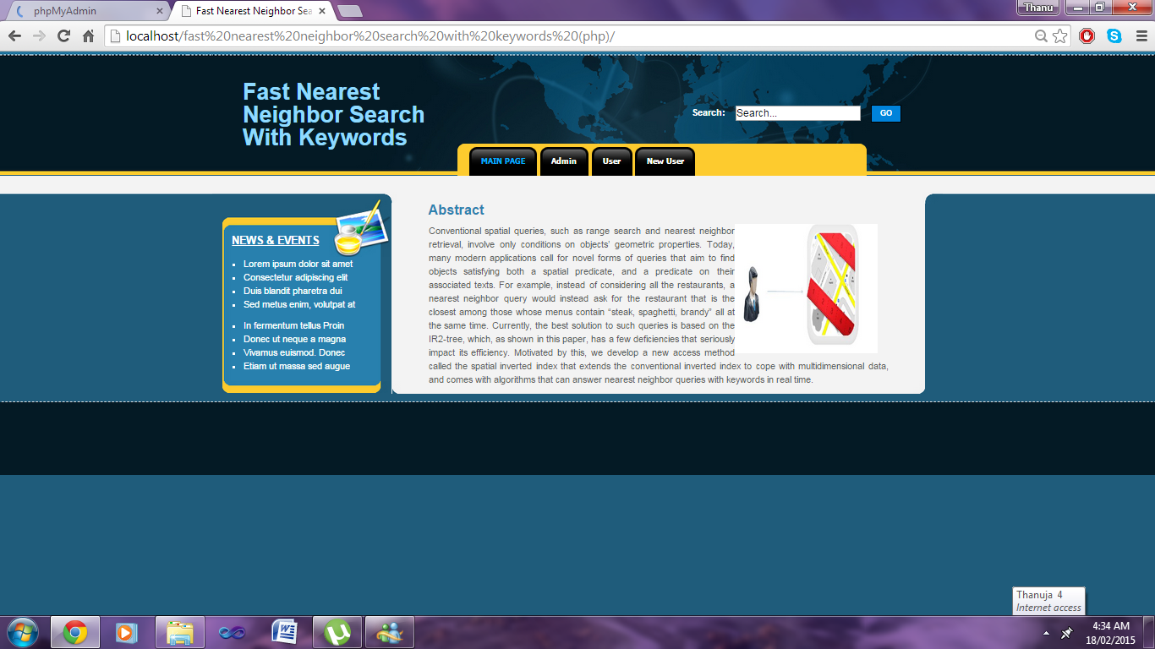

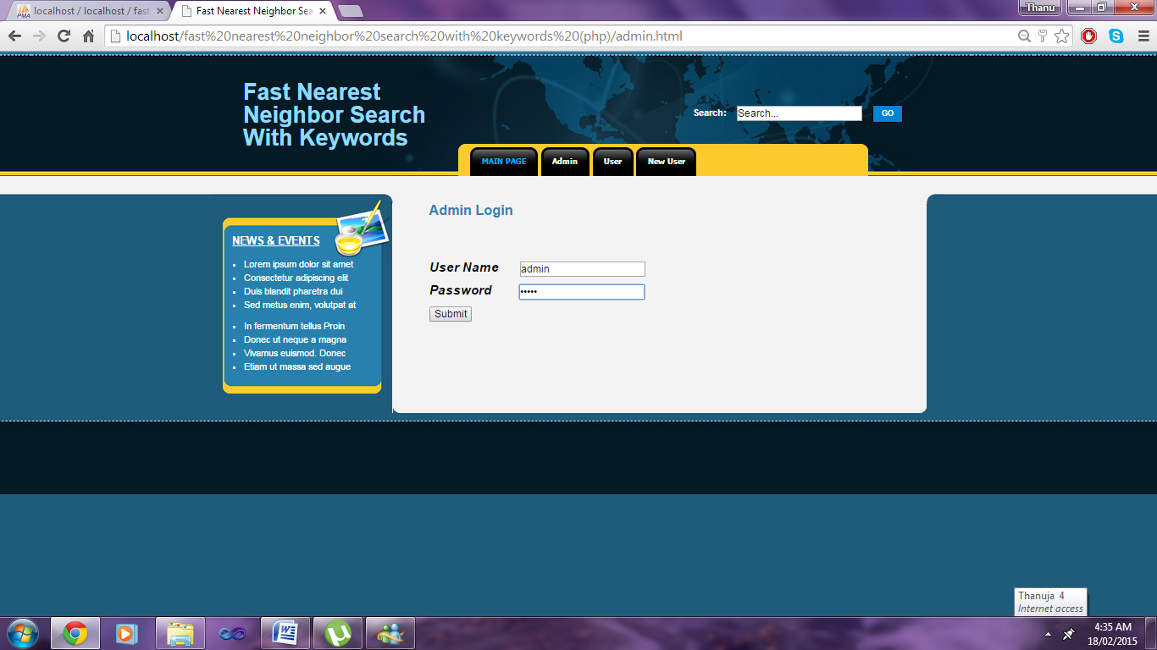

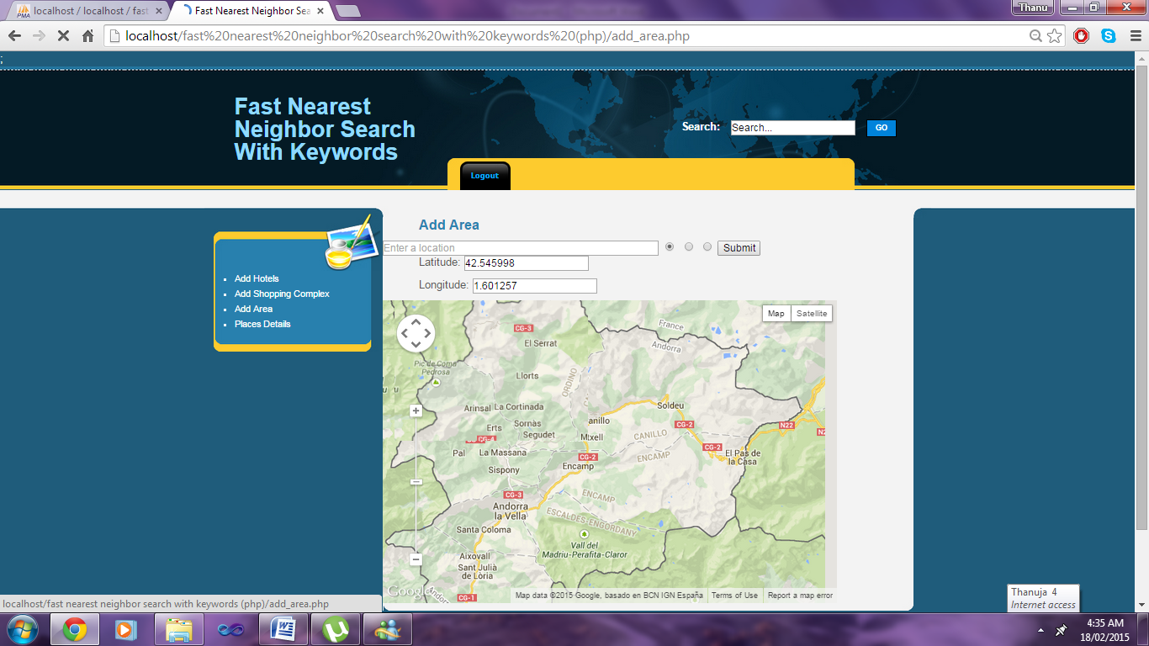

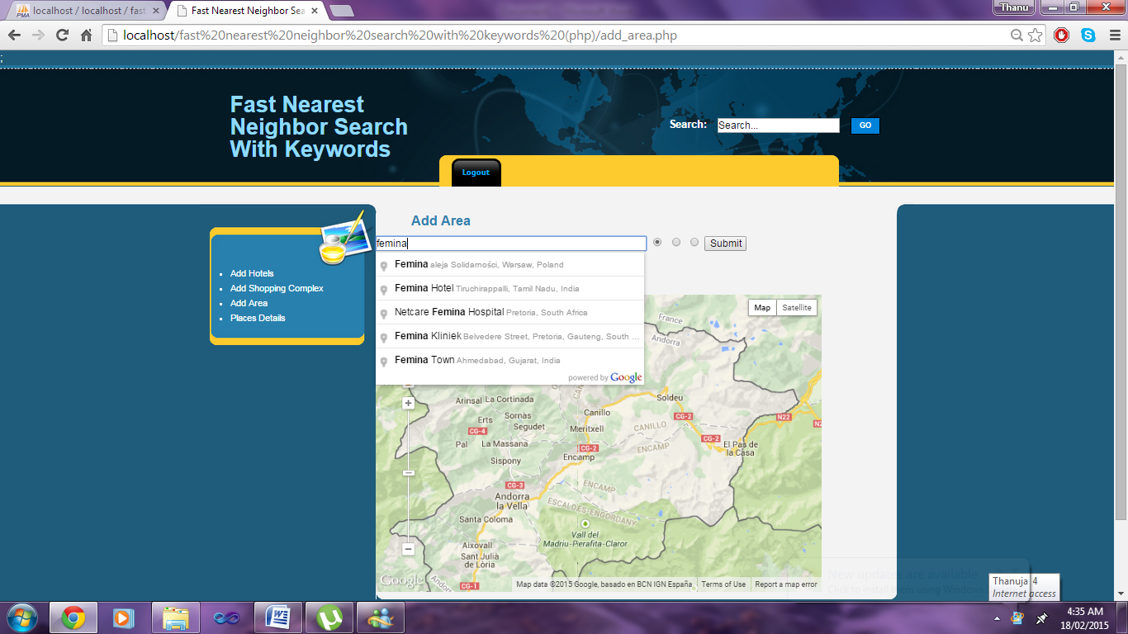

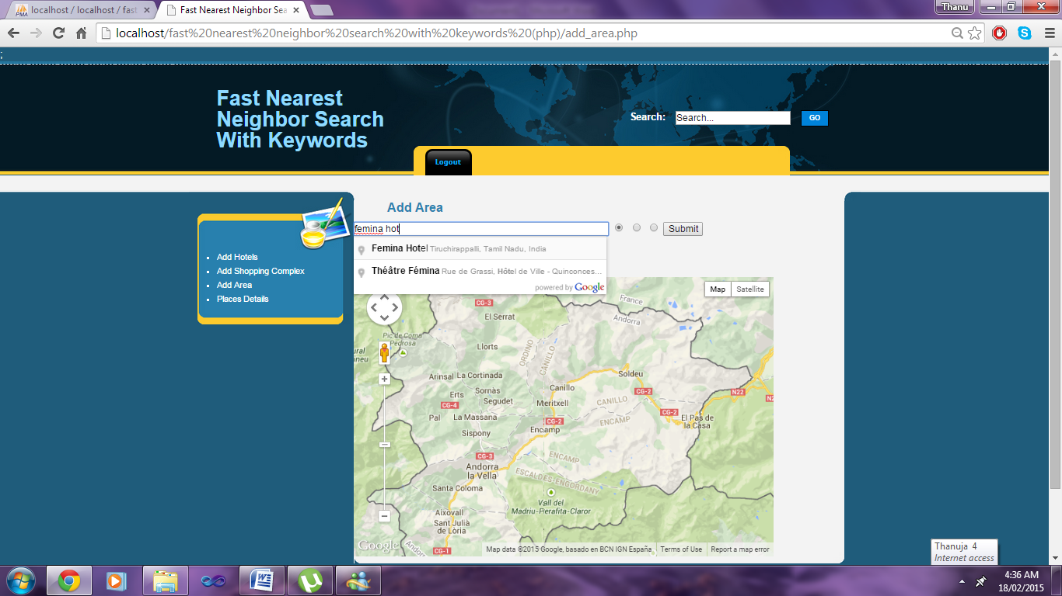

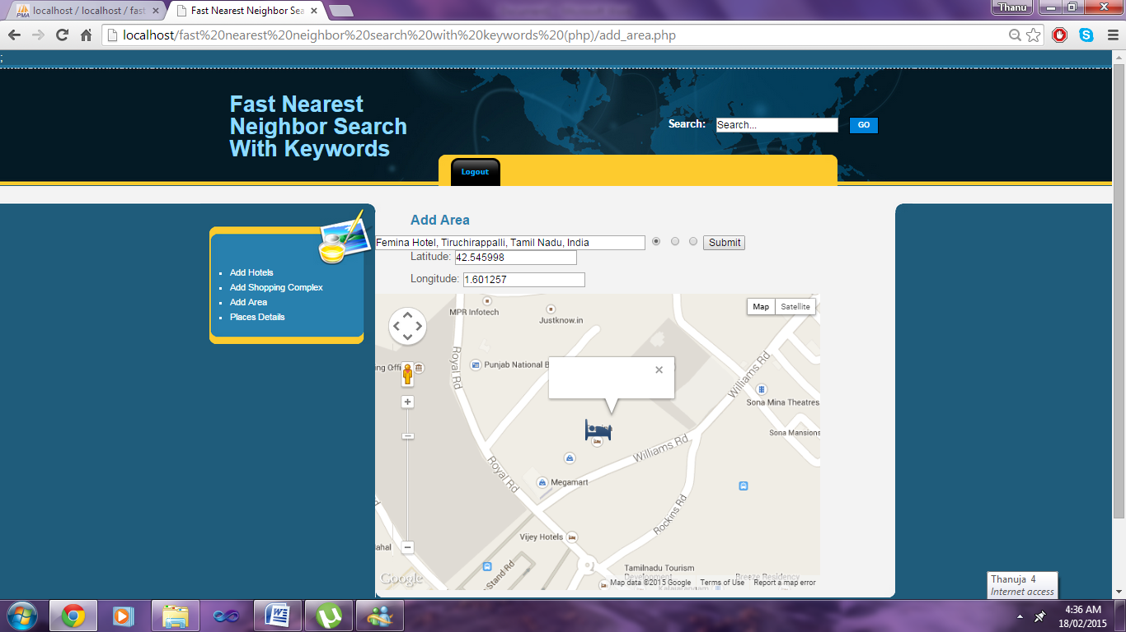

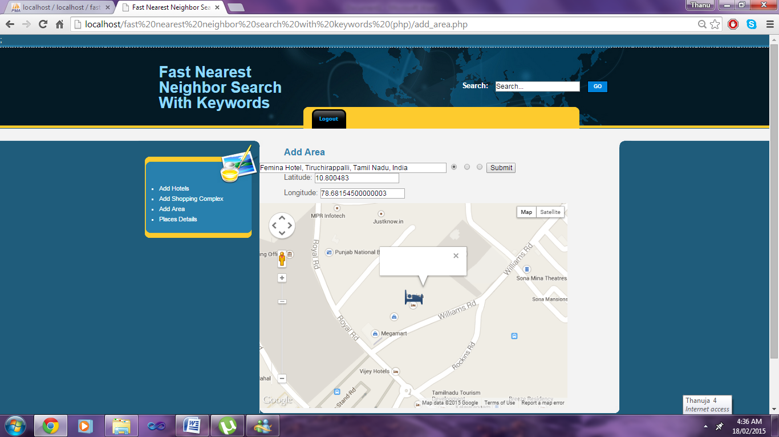

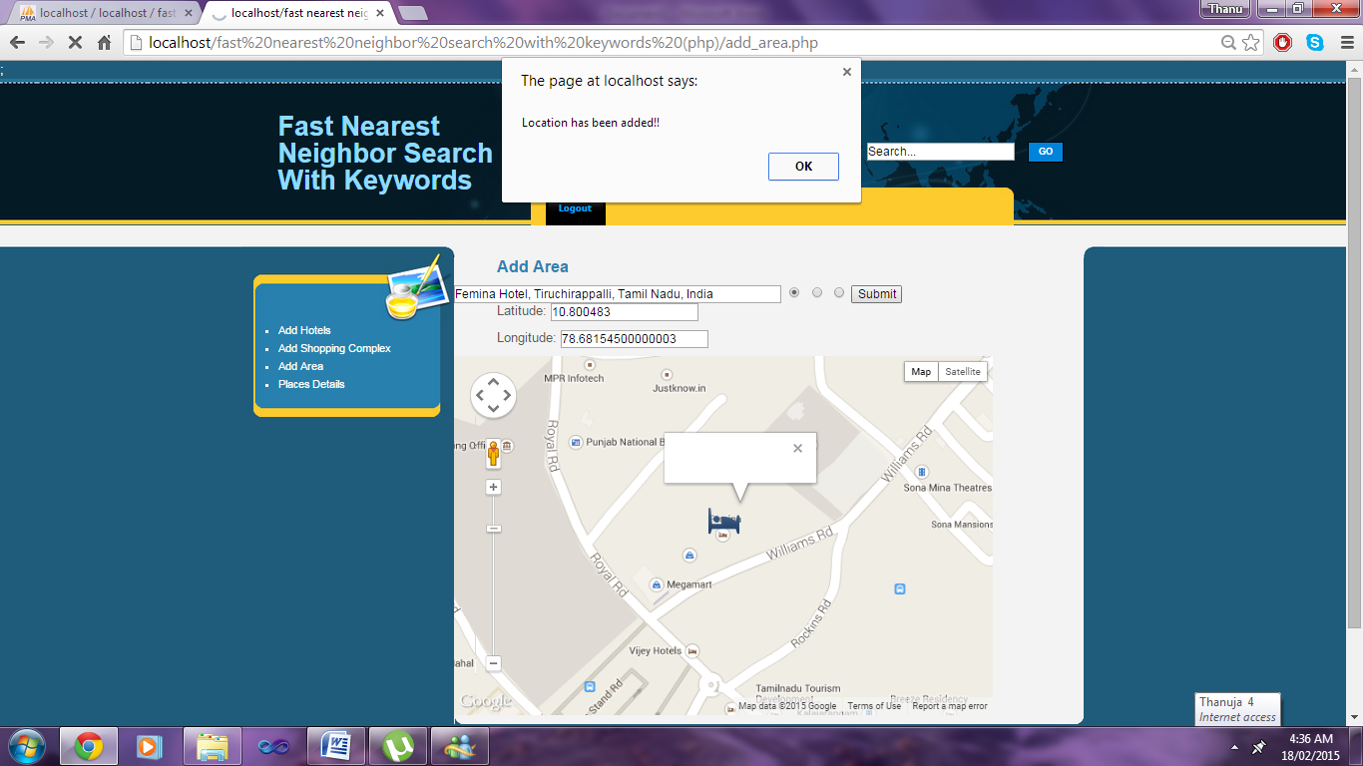

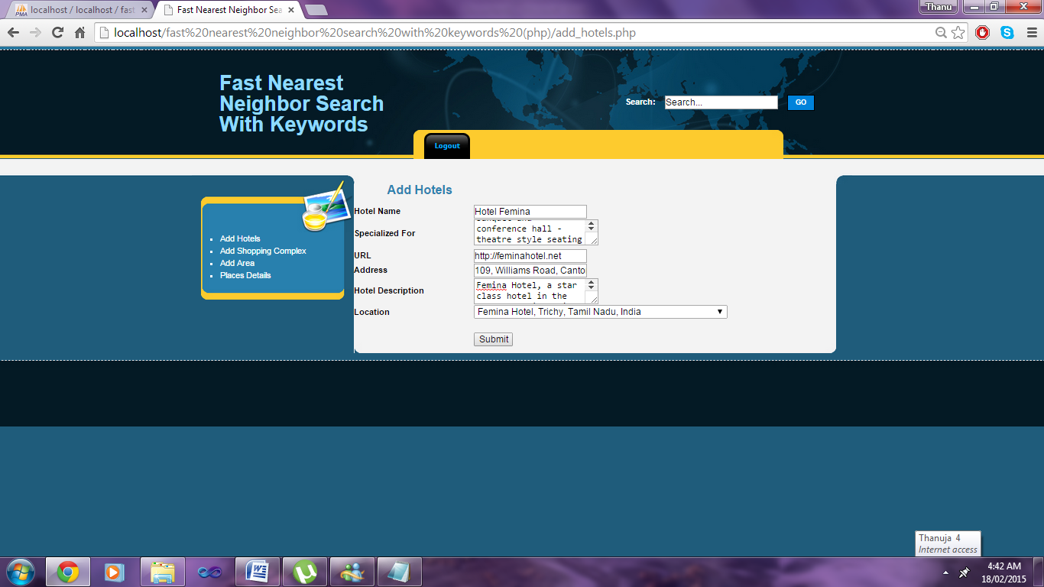

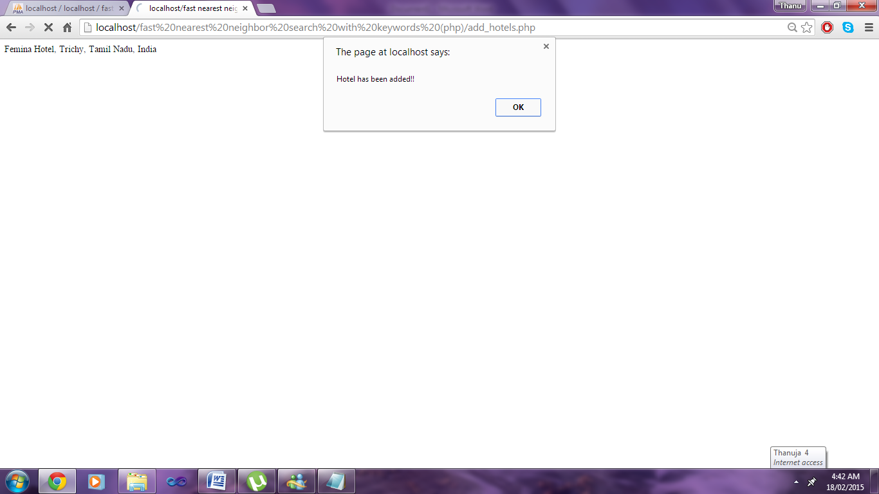

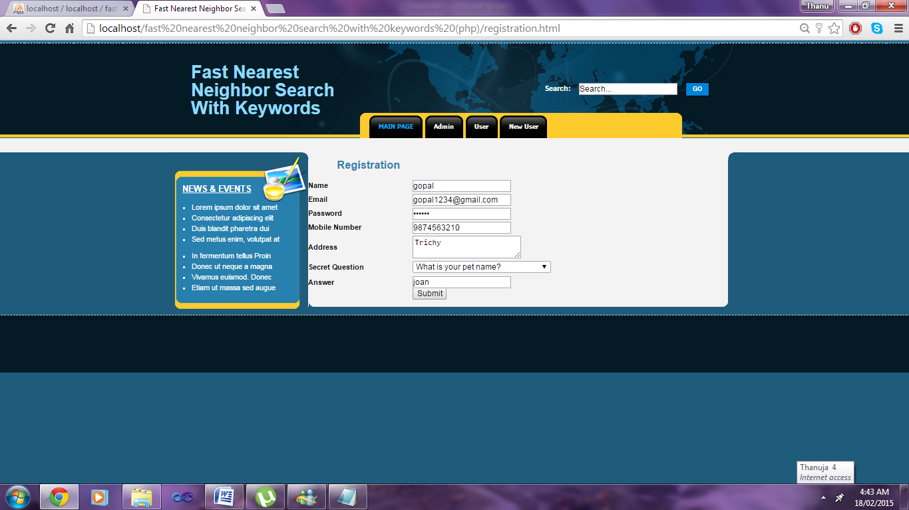

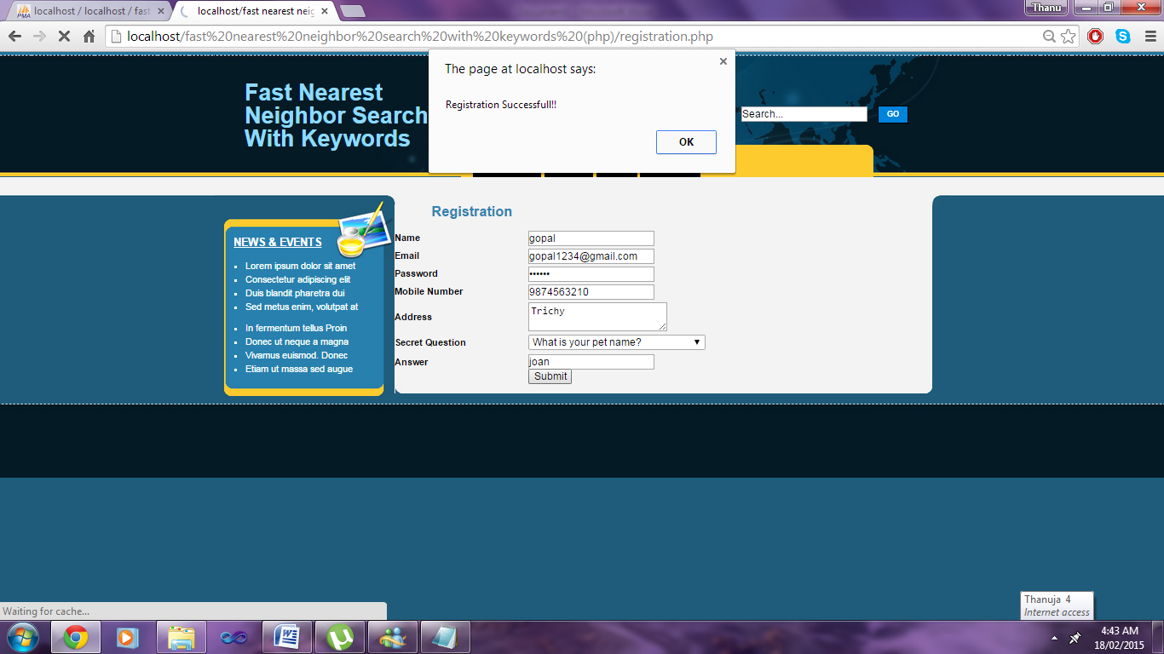

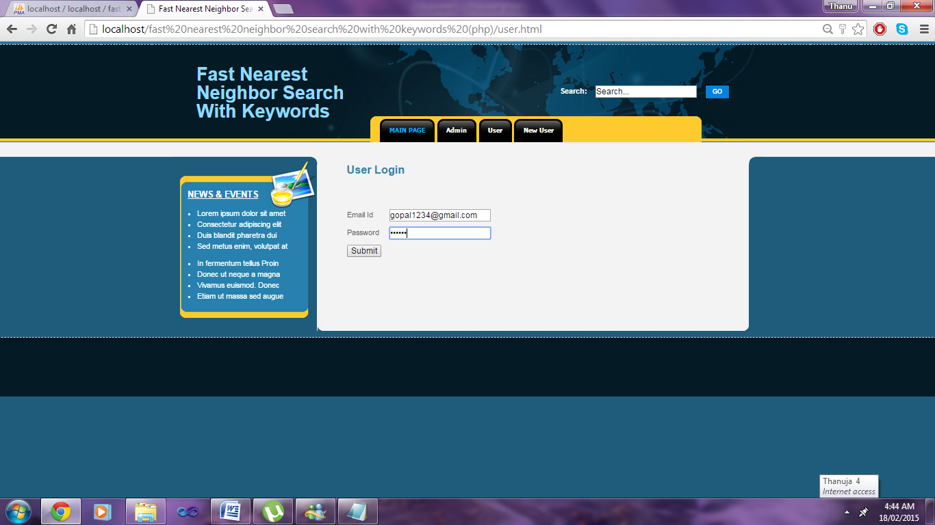

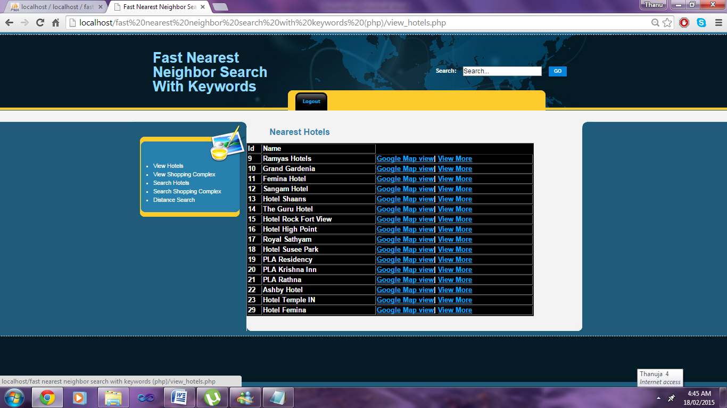

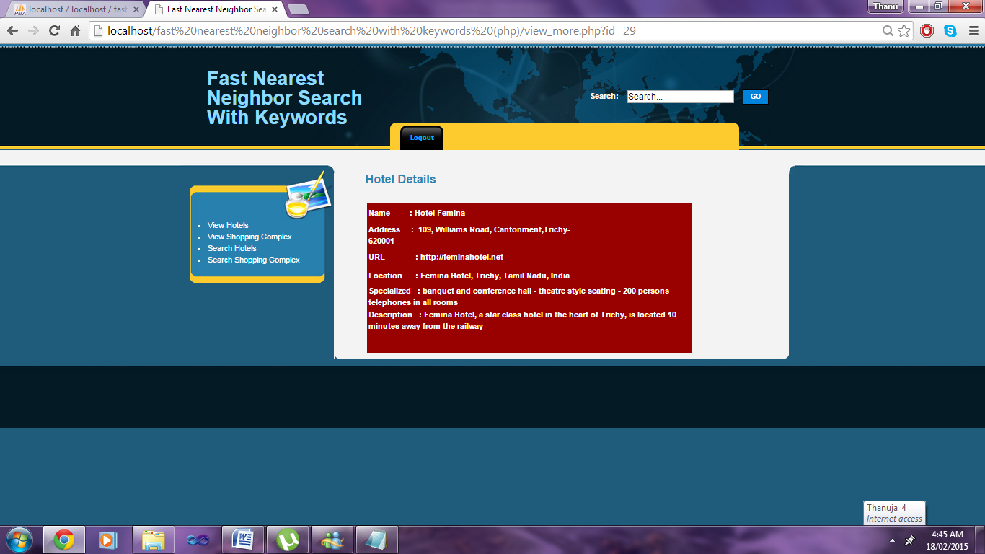

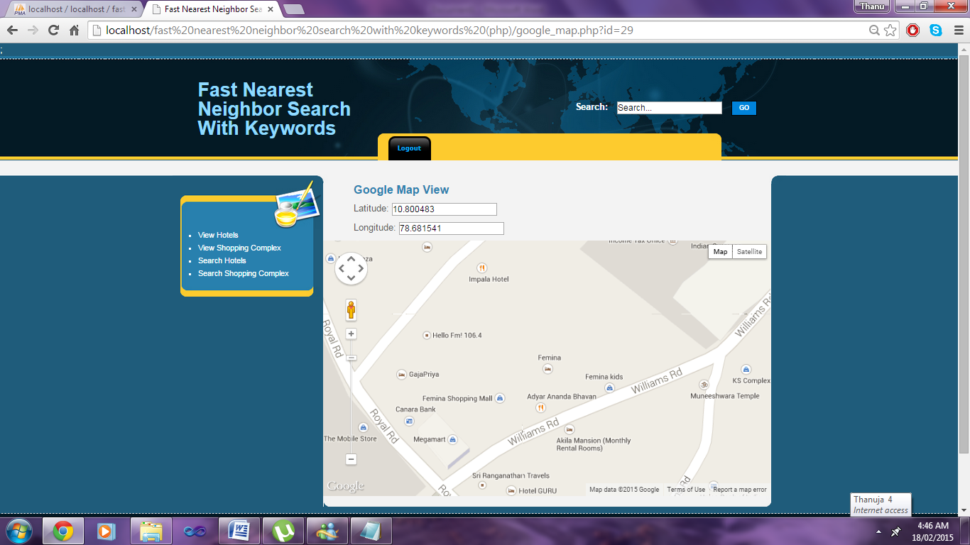

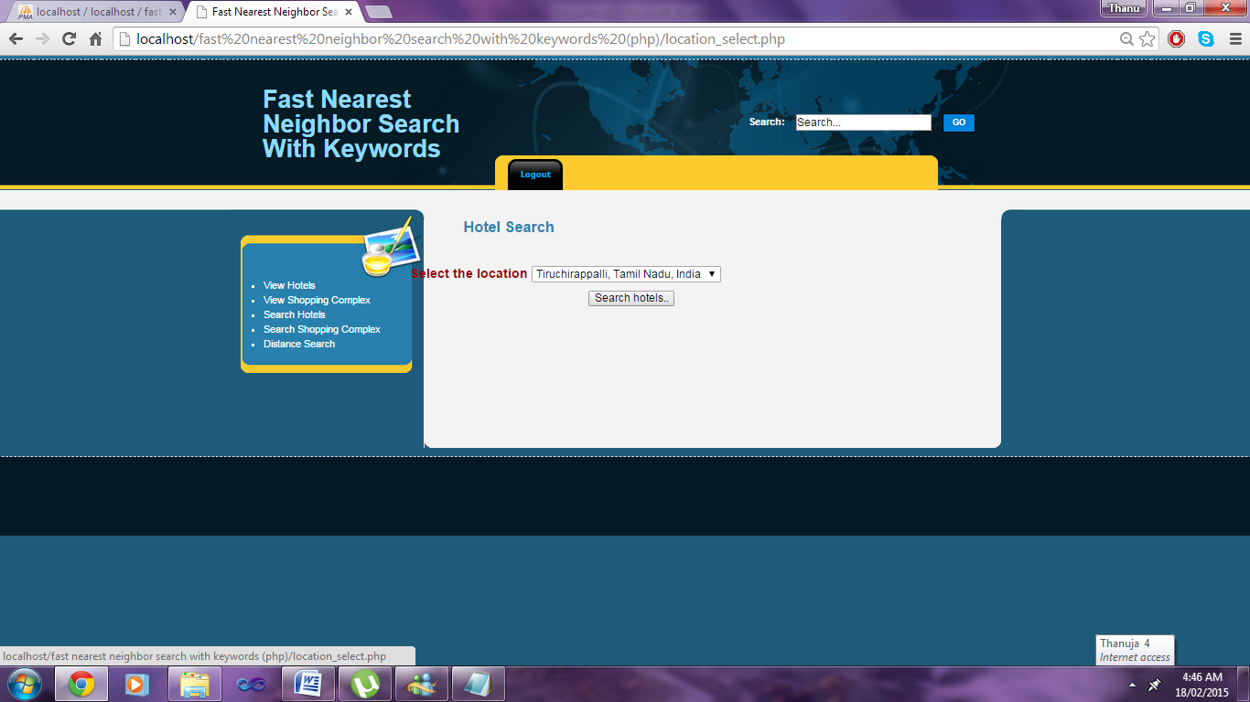

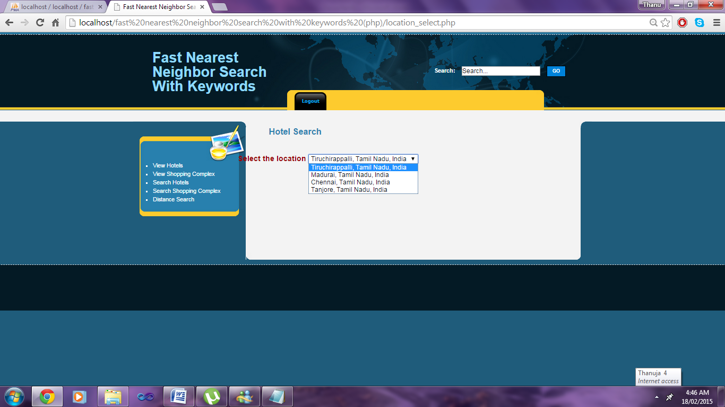

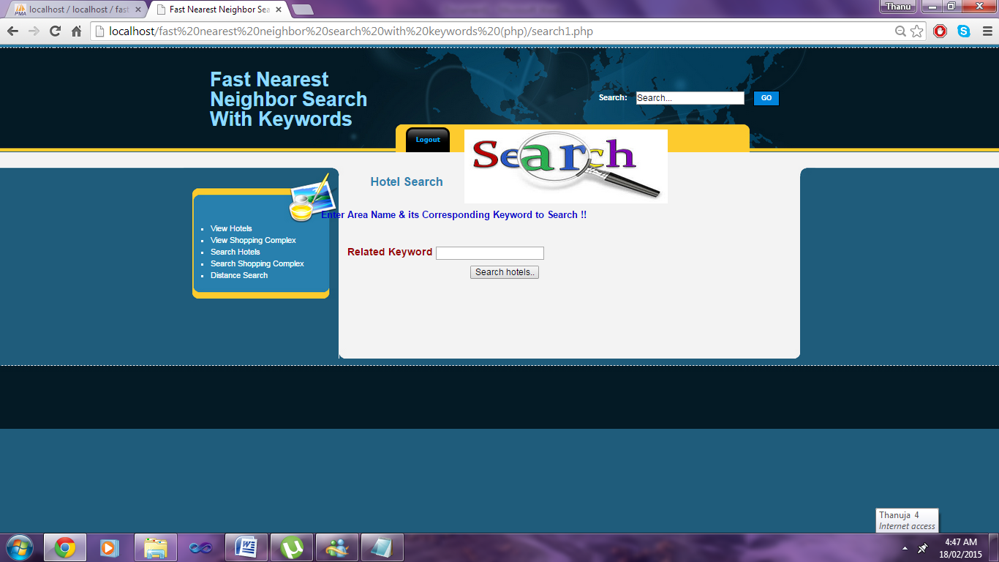

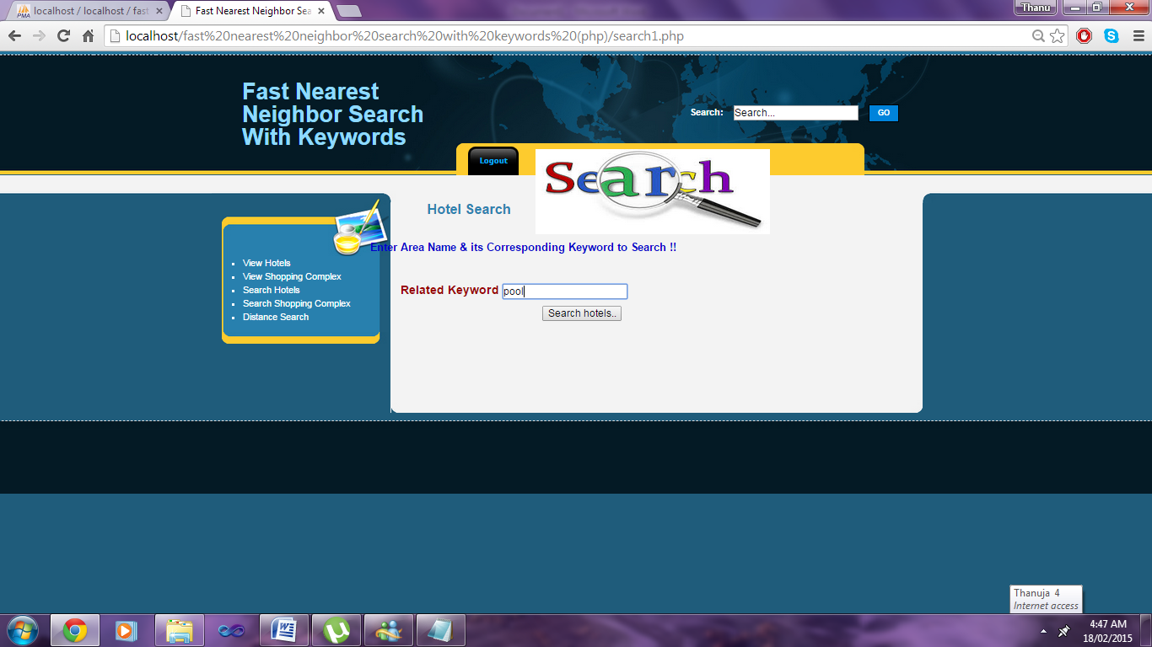

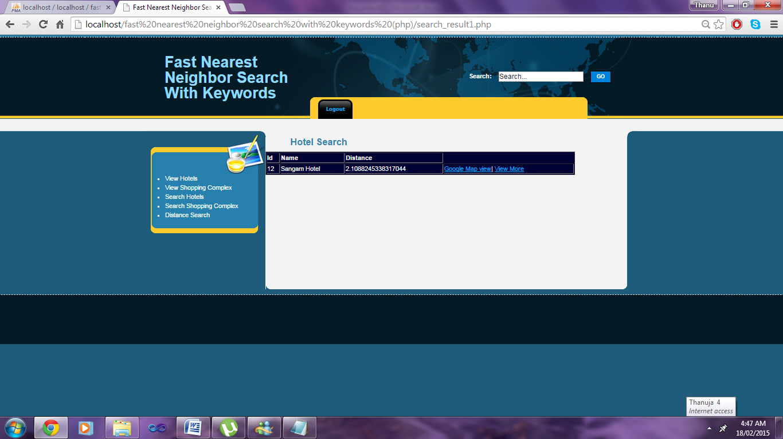

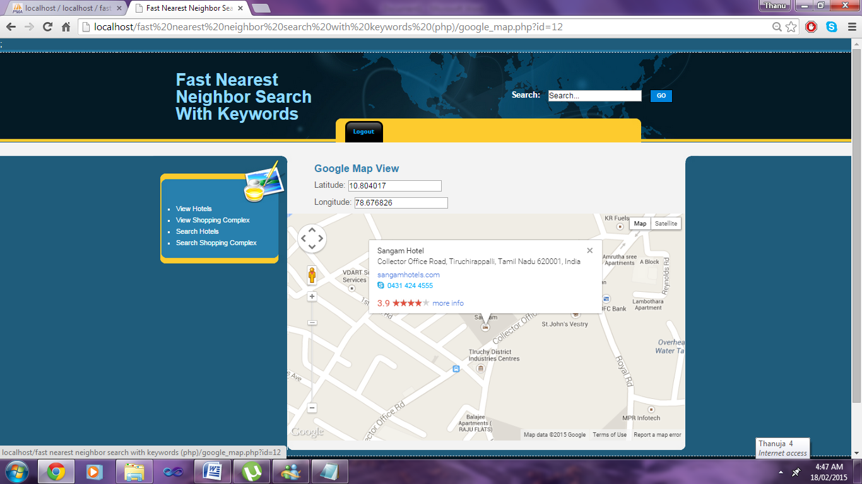

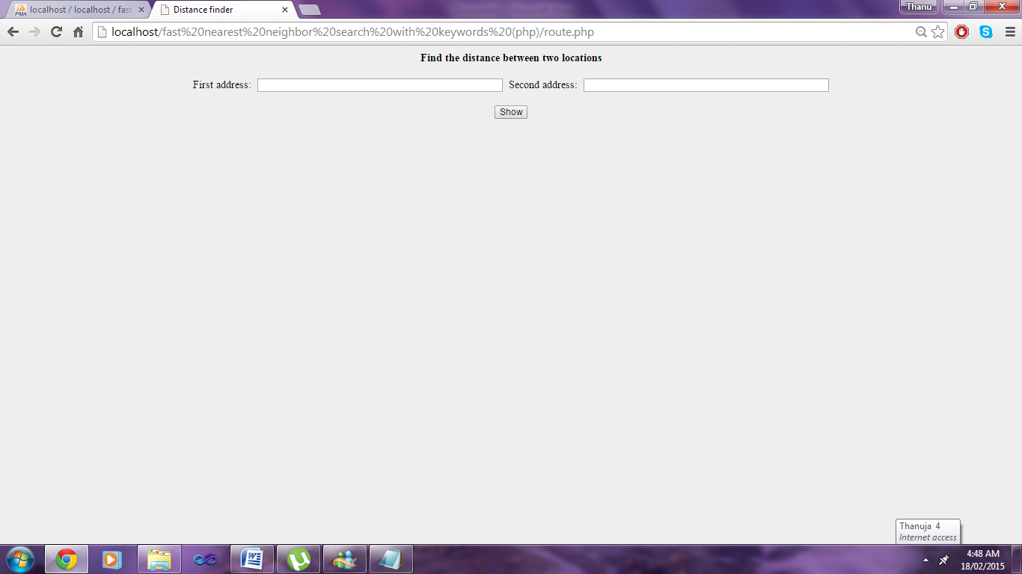

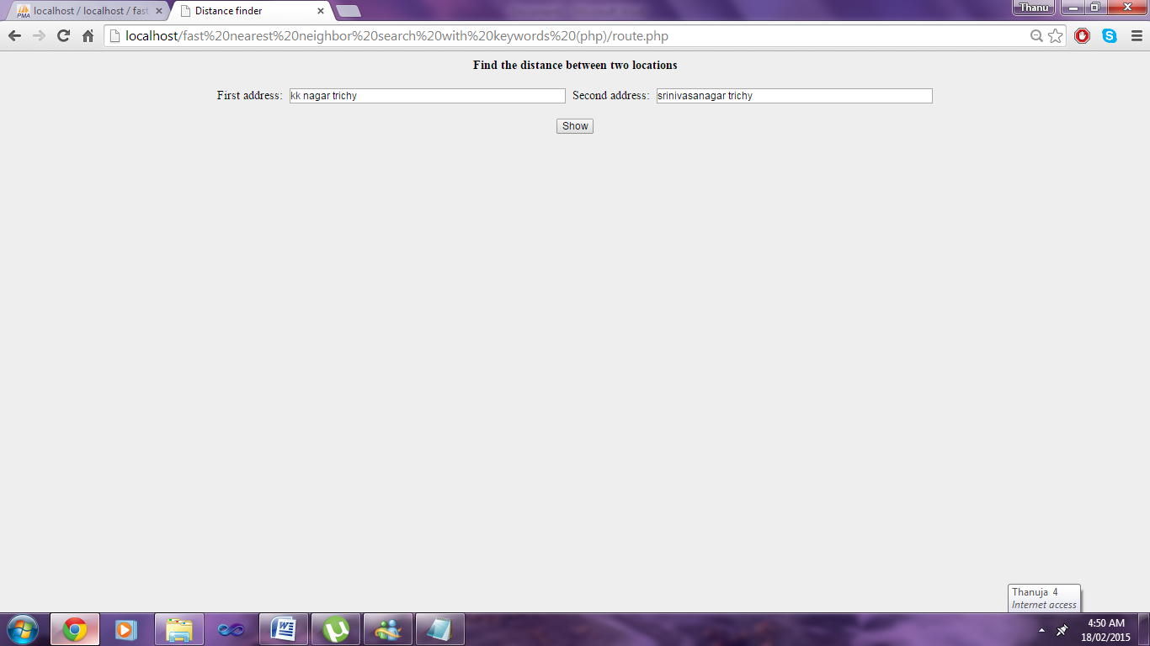

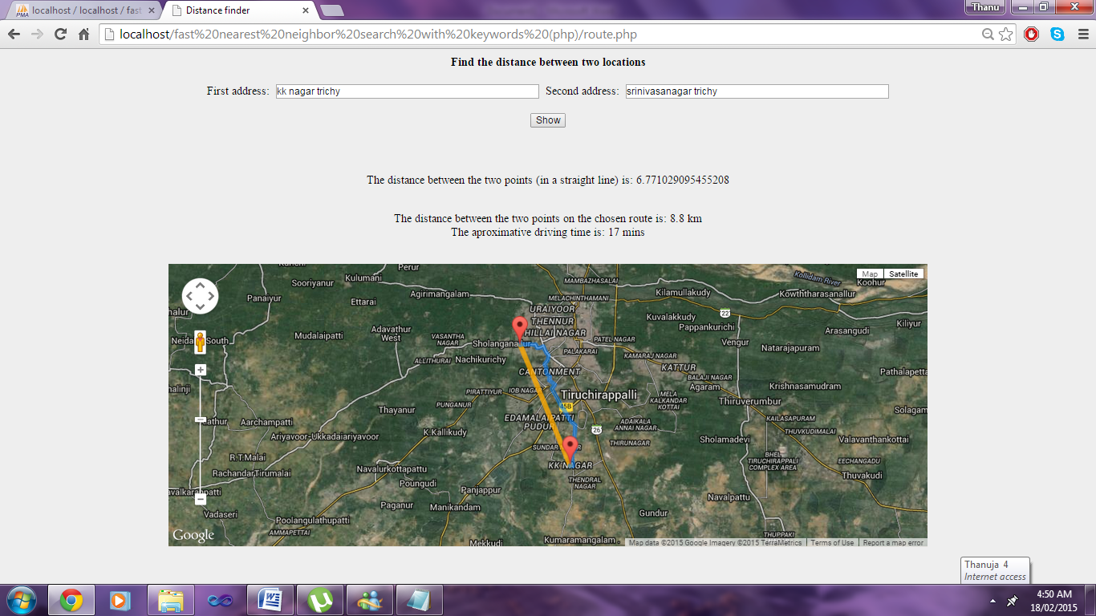

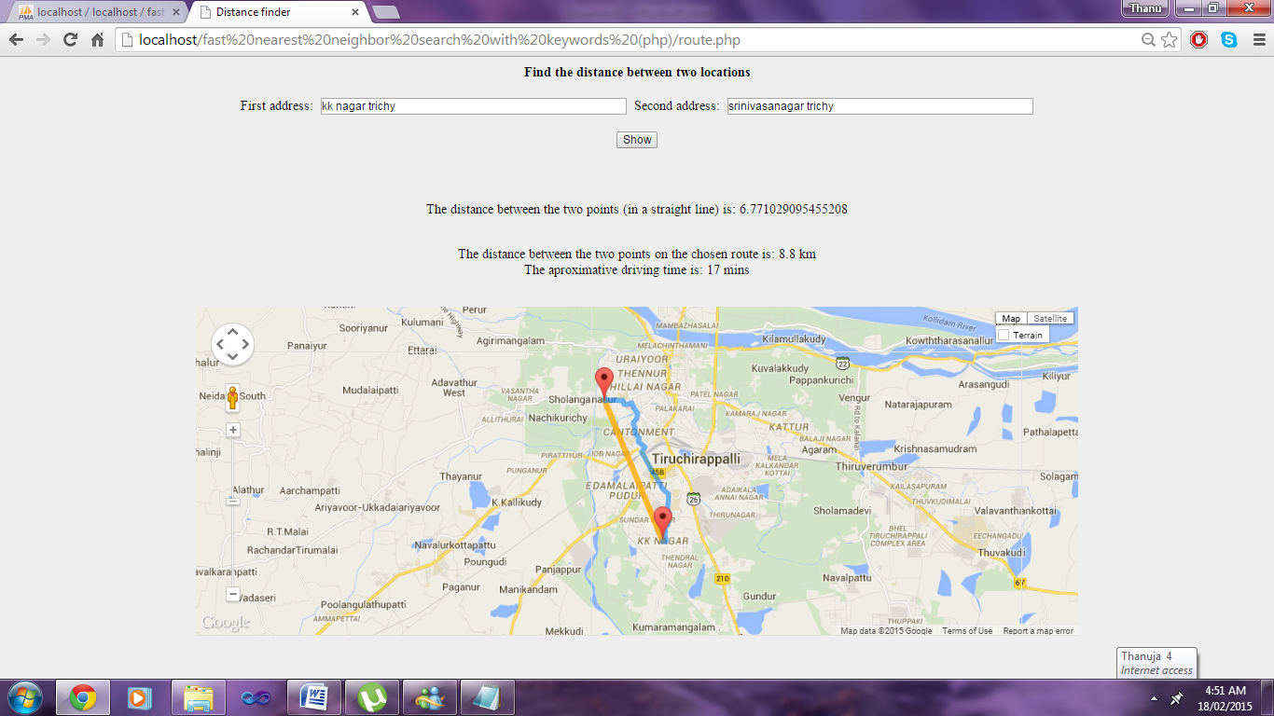

**Conclusion:**

There are plenty of applications calling for a search engine that is able to efficiently support novel forms of spatial queries that are integrated with keyword search. The existing solutions to such queries either incur prohibitive space consumption or are unable to give real time answers. In this paper, the method remedied the situation by developing an access method called the spatial inverted index (SI-index). Not only that the SI-index is fairly space economical, but also it has the ability to perform keyword-augmented nearest neighbor search in time that is at the order of dozens of milli-seconds. Furthermore, as the SI-index is based on the conventional technology of inverted index, it is readily incorporable in a commercial search engine that applies massive parallelism, implying its immediate industrial merits.

CHAPTER 9

# CONCLUTION AND FUTURE ENHANCEMENT

Moderate improvements in performance should be obtainable by further tuning of the implementation. Beyond these optimizations, planned to study pruning techniques for geographic search engines that can produce top-k results without computing the precise scores of all documents in the result set. Such techniques could combine early termination approaches from search engines with the use of approximate (lossy-compressed) footprint data. Pruning techniques for geographic search engines are an interesting topic for future research, but the major goal is to first understand the general case.

**REFERENCES**

[1] S. Agrawal, S. Chaudhuri, and G. Das, “Dbxplorer: A System for Keyword-Based Search over Relational Databases,” Proc. Int’l Conf. Data Eng. (ICDE), pp. 5-16, 2002.

[2] N. Beckmann, H. Kriegel, R. Schneider, and B. Seeger, “The R - tree: An Efficient and Robust Access Method for Points and Rectangles,” Proc. ACM SIGMOD Int’l Conf. Management of Data, pp. 322-331, 1990.

[3] G. Bhalotia, A. Hulgeri, C. Nakhe, S. Chakrabarti, and S. Sudarshan, “Keyword Searching and Browsing in Databases Using Banks,” Proc. Int’l Conf. Data Eng. (ICDE), pp. 431-440, 2002.

[4] X. Cao, L. Chen, G. Cong, C.S. Jensen, Q. Qu, A. Skovsgaard, D. Wu, and M.L. Yiu, “Spatial Keyword Querying,” Proc. 31st Int’l Conf. Conceptual Modeling (ER), pp. 16-29, 2012.

[5] X. Cao, G. Cong, and C.S. Jensen, “Retrieving Top-k Prestige-Based Relevant Spatial Web Objects,” Proc. VLDB Endowment, vol. 3, no. 1, pp. 373-384, 2010.

[6] X. Cao, G. Cong, C.S. Jensen, and B.C. Ooi, “Collective Spatial Keyword Querying,” Proc. ACM SIGMOD Int’l Conf. Management of Data, pp. 373-384, 2011.

[7] B. Chazelle, J. Kilian, R. Rubinfeld, and A. Tal, “The Bloomier Filter: An Efficient Data Structure for Static Support Lookup Tables,” Proc. Ann. ACM-SIAM Symp. Discrete Algorithms (SODA), pp. 30-39, 2004.

**CHAPTER 10**

**BIBLIOGRAPHY**

The following books were referred during the analysis and execution phase of the project

**CORE JAVA™ 2 VOLUME II – ADVANCED - PEARSON EDUCATION – SUN MICROSYSTEMS.\**

- Cay S. Hortsman and Gary Cornell

**DATABASE PROGRAMMING WITH JDBC AND JAVA**

O'Reilly

**JAVA AND SOFTWARE DESIGN CONCEPTS BY APRESS**

Apress Publications

**WEBSITES REFERNCES:**

* + https://[www.tutorialspoint.com/java/](http://www.tutorialspoint.com/java/)
  + <http://www.javatpoint.com/java-tutorial>
  + https://docs.oracle.com/javase/tutorial/
  + <http://www.wampserver.com/en/>
  + <http://www.JSP.net/>
  + <http://www.tutorialspoint.com/mysql/>
  + httpd.apache.org/docs/2.0/misc/tutorials.html